Title of the abstract

Photo

30 ×25 mm

Presenting author
Affiliation
e-mail address

The text should be given in English using MS Word formats (12-point font Times New Roman). The text should not occupy more than one full A4 page.
Next page is an example.

References
- Author, Journal, Year, vol, page.

Use of phase transition

Photo

30 ×25 mm

for electrochemical thermoelectric conversion

Teppei Yamada
Department of Chemistry, The University of Tokyo
teppei@chem.s.u-tokyo.ac.jp

Thermocells are the emerging class of thermoelectric conversion devices. It consists of the solution of the redox species, and the temperature dependence of the redox equilibrium provides the thermoelectric voltage by temperature gradient.
We have challenged to improve the performance of the thermocell, by introducing host-guest chemistry^{1,2}, PCET reaction^{3,4}, use of mixed solvent⁵ or deep-eutectic solvent⁶ and the improvement of cell configuration⁷.
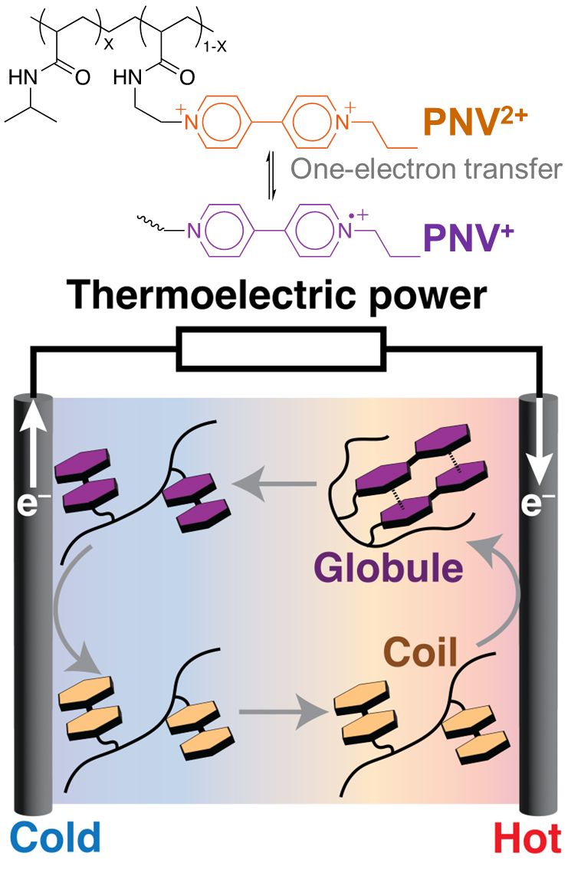
The thermoelectric voltage is one of the important parameters for improving the thermoelectric conversion efficiency. We recently focused on the redox-correlated phase transition phenomena because it shows the drastic change within the small temperature difference. We modified the viologen unit into poly-(N-isopropyl)acrylamide (PNIPAM). PNIPAM is widely known to show phase-transition between hydrophilic coil- to hydrophobic globule conformations.⁸ The phase transition temperature changes by changing the redox state of viologen site, and as a result we can change the phase of the polymer by external electric current. Also, the redox potential shifts by the phase transition and produce thermoelectric voltage associated with the phase transition entropy.
By modifying carboxyl groups onto PNIPAM, the pH of the solvent changes by changing temperature. We succeeded in changing the redox potential of quinhydrone (1:1 mixture of p-quinone and p-hydroquinone) by changing pH. The Seebeck coefficient (obtained voltage by unit temperature difference) of the system reaches −6.2 mV/K, and +6.6 mV/K by modifying amino groups instead of carboxyl groups.
I would like to provide our recent effort on the correlation of redox reaction and micelle formation or plastic crystal phase transition.
References
- T. Yamada, N. Kimizuka, H. Zhou et al., Sustain. Energy Fuels, 2024, 8, 684.
- H. Inoue, H. Zhou, H. Ando, S. Nakagawa, T. Yamada, Chem. Sci., 2023, 15, 146.
- N. F. Antariksa, T. Yamada, N. Kimizuka, Sci. Rep., 2021, 11, 11929.
- H. Zhou, T. Yamada et al., J. Power Sources, 2024, 614, 235048.

